2025 TEEP Progress Report Week-14
Used Wokwi to complete the tasks for Labs 1 and 2
(Before creating the physical project, please use Wokwi for online simulation to complete the initial design of the circuit and code. Then, use Thonny together with the ESP32 development board to build the actual project. Please record a video of the project in operation, upload it to YouTube, and provide the video link(LAB7) so we can better understand your learning progress.)

Lab1 – On ESP32, complete the following tasks:
This project focuses on optimizing the single-cell battery charging monitoring system completed last week, with the goal of improving the overall stability of measurement and display. Each step of the experimental process must be thoroughly documented, compiled into the project report, and also presented in video format to ensure completeness and traceability of the research process.
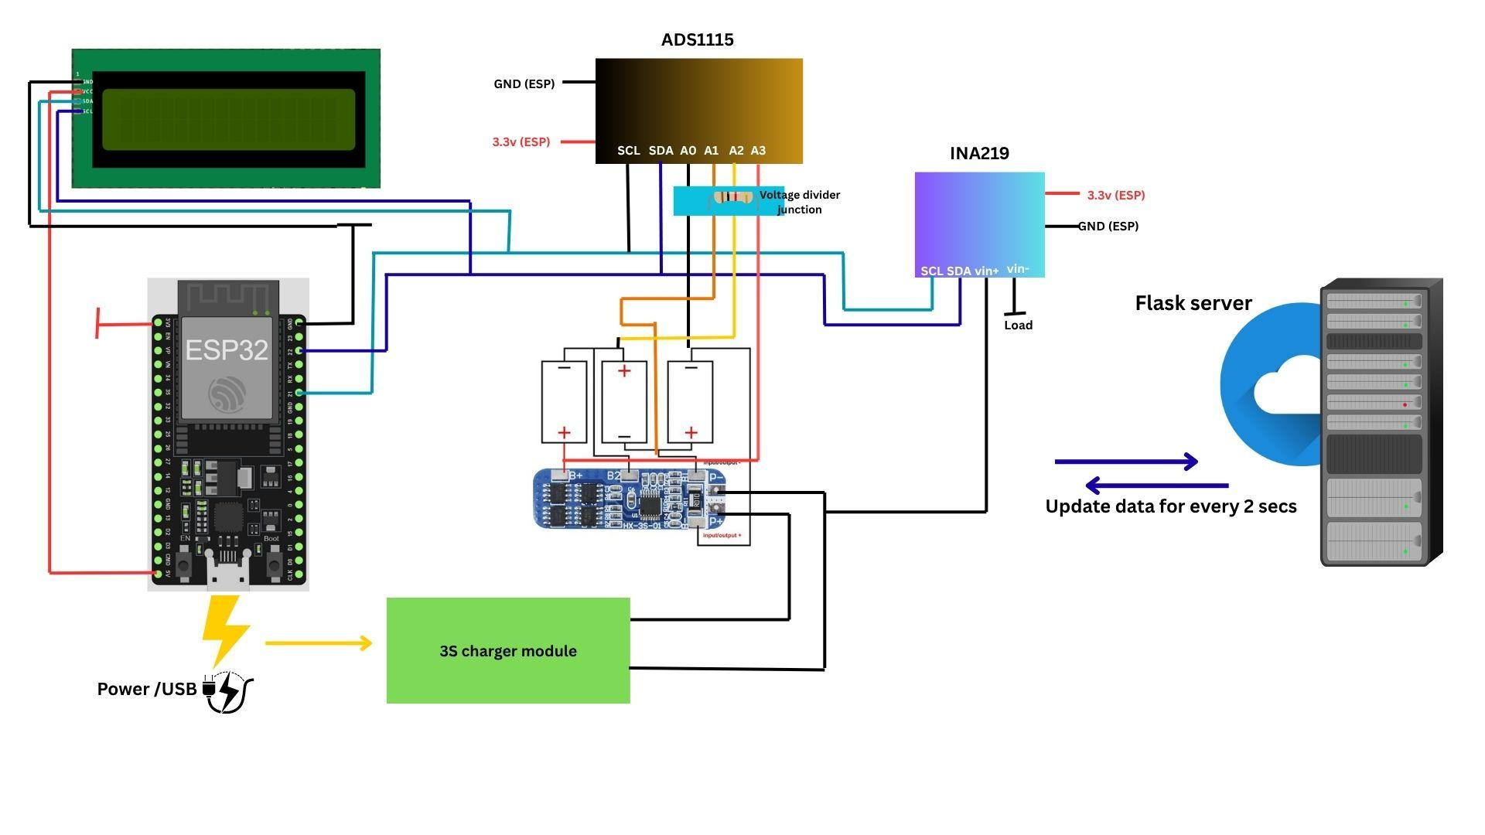

Connections :
Battery Setup:
- Three Li-Ion cells connected in series to form a 3S pack (≈12.6 V fully charged).
- BMS module connected to balance and protect the cells during charging and discharging.
Sensor Connections:
- INA219 placed between the pack’s output (BMS P− terminal) and the system ground to measure charging/discharging current.
- ADS1115 connected via I²C to ESP32 to measure voltages through voltage dividers:
  - A0 → Cell 1 (3.7 V max)
  - A1 → Cell 1 + 2 (≈7.4 V max)
  - A2 → Total pack (≈12.6 V max)
ESP32 and Peripherals:
- ESP32 connected to I²C devices:
  - ADS1115 (SDA = GPIO21, SCL = GPIO22)
  - INA219 (same I²C bus)
  - 16x2 LCD (I²C address = 0x27)
- Wi-Fi credentials configured to enable data transfer to the Flask server.
Programming:
- ESP32 programmed using Thonny (MicroPython).
- Code reads:
  - Individual cell voltages from ADS1115
  - Current and pack voltage from INA219
- Microcontroller calculates:
  - Each cell’s voltage
  - Total pack voltage
  - Charging/discharging current
  - Battery percentage (SoC) and status
- EMA smoothing applied to reduce fluctuations in voltage and SoC readings.
Data Display and Communication:
- 16x2 LCD displays pack voltage and battery percentage in real time.
- ESP32 uploads the smoothed data to a Flask web server via Wi-Fi for remote monitoring.
- Flask dashboard displays live data and voltage trends graphically, providing stable and readable charts thanks to the smoothing algorithm.

Flowchart :
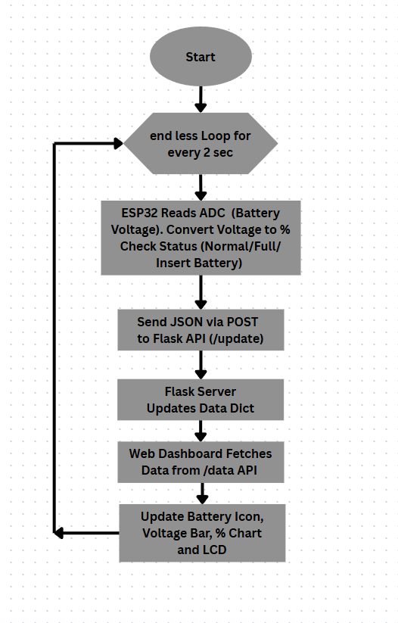

Source Code :
main.py
from machine import Pin, I2C
import network, urequests, time

# I2C Configuration
i2c = I2C(0, scl=Pin(22), sda=Pin(21), freq=100000)
ADS_ADDR, INA_ADDR, LCD_ADDR = 0x48, 0x40, 0x27
SSID, PASSWORD = "ISILAB CR", "isilab.ncut.CR"
URL = "http://192.168.50.205:5000/update"

# Wi-Fi Connection
wifi = network.WLAN(network.STA_IF)
wifi.active(True)
wifi.connect(SSID, PASSWORD)
while not wifi.isconnected():
time.sleep(0.5)
print("Connected:", wifi.ifconfig())

# LCD Driver
class I2CLcd:
def __init__(self, i2c, addr, rows=2, cols=16):
self.i2c, self.addr = i2c, addr
self.backlight = 0x08
self._init_lcd()
def _cmd(self, c):
self.i2c.writeto(self.addr, bytes([c & 0xF0 | self.backlight]))
self.i2c.writeto(self.addr, bytes([(c << 4) & 0xF0 | self.backlight]))
time.sleep_ms(2)
def _char(self, c):
self.i2c.writeto(self.addr, bytes([c & 0xF0 | 0x01 | self.backlight]))
self.i2c.writeto(self.addr, bytes([(c << 4) & 0xF0 | 0x01 | self.backlight]))
time.sleep_ms(1)
def _init_lcd(self):
for c in [0x33,0x32,0x06,0x0C,0x28,0x01]: self._cmd(c)
def clear(self): self._cmd(0x01)
def move_to(self, r,c): self._cmd(0x80 | (c + 0x40*r))
def putstr(self, s): [self._char(ord(ch)) for ch in s]

lcd = I2CLcd(i2c, LCD_ADDR)

# ADS1115 Voltage Reading
def read_ads(ch):
config = 0x8400 | (ch << 12) | 0x0083
i2c.writeto_mem(ADS_ADDR, 0x01, config.to_bytes(2,'big'))
time.sleep(0.01)
raw = int.from_bytes(i2c.readfrom_mem(ADS_ADDR, 0x00, 2),'big')
if raw > 32767: raw -= 65536
return raw * 4.096 / 32768

def get_cells():
v1 = read_ads(0)*2
v12 = read_ads(1)*3
v123 = read_ads(2)*4
return v1, v12-v1, v123-(v12), v123

# INA219 Current Reading
def read_ina219():
i2c.writeto_mem(INA_ADDR, 0x05, (4096).to_bytes(2,'big'))
bus_v = (int.from_bytes(i2c.readfrom_mem(INA_ADDR,0x02,2),'big')>>3)*0.004
sh = int.from_bytes(i2c.readfrom_mem(INA_ADDR,0x01,2),'big')
if sh > 32767: sh -= 65536
cur = (sh*0.01/1000)/0.1
return bus_v, cur
alpha=0.2
def ema(prev,new): return new if prev is None else prev*(1-alpha)+new*alpha
ema_c1=ema_c2=ema_c3=ema_pack=ema_soc=ema_cur=None

def soc_calc(v): return max(0,min(100,int((v-9)/(12.6-9)*100)))

while True:
try:
c1,c2,c3,pack = get_cells()
vbus,cur = read_ina219()
soc = soc_calc(pack)
ema_c1,ema_c2,ema_c3 = ema(ema_c1,c1),ema(ema_c2,c2),ema(ema_c3,c3)
ema_pack,ema_soc,ema_cur = ema(ema_pack,pack),ema(ema_soc,soc),ema(ema_cur,cur)
data={"cell1":round(ema_c1,2),"cell2":round(ema_c2,2),"cell3":round(ema_c3,2),
"pack":round(ema_pack,2),"current":round(ema_cur,2),"soc":int(ema_soc)}
urequests.post(URL,json=data)
lcd.clear()
lcd.move_to(0,0); lcd.putstr("Pack:{:.2f}V".format(ema_pack))
lcd.move_to(1,0); lcd.putstr("SoC:{}%".format(int(ema_soc)))
time.sleep(2)
except Exception as e:
print("Error:", e)
time.sleep(2)

app.py
from flask import Flask, render_template, request, jsonify
from datetime import datetime
app = Flask(__name__)

battery_data = {"cell1":0,"cell2":0,"cell3":0,"pack":0,"current":0,"soc":0,"status":"Idle","timestamp":None}

@app.route('/')
def index(): return render_template('index.html')

@app.route('/update', methods=['POST'])
def update_data():
global battery_data
d = request.get_json()
if d:
battery_data.update(d)
battery_data["timestamp"] = datetime.now().strftime("%H:%M:%S")
if battery_data["current"] > 0.2: battery_data["status"]="Charging"
elif battery_data["soc"]>=98: battery_data["status"]="Full"
else: battery_data["status"]="Idle"
return jsonify({"message":"Data received"})

@app.route('/data')
def data(): return jsonify(battery_data)

if __name__ == '__main__':
app.run(host='0.0.0.0', port=5000, debug=True)

Index.html
<!DOCTYPE html>
<html lang="en">
<head>
<meta charset="UTF-8">
<title>Smart Battery Dashboard</title>
<script src="https://cdn.jsdelivr.net/npm/chart.js"></script>
<style>
body{font-family:Poppins,sans-serif;background:#f3f6fa;margin:0;text-align:center;color:#333}
h1{background:#2d6cdf;color:#fff;margin:0;padding:20px;font-weight:500;box-shadow:0 2px 8px rgba(0,0,0,0.2)}
.card{background:#fff;border-radius:15px;box-shadow:0 2px 10px rgba(0,0,0,0.1);padding:15px;width:250px;margin:10px auto;display:inline-block;}
.bar-container{background:#e0e0e0;border-radius:8px;height:20px;overflow:hidden}
.bar{height:100%;width:0;background:linear-gradient(90deg,#47cf73,#2d6cdf);transition:width 0.5s}
#chart-container{width:90%;max-width:1000px;margin:30px auto;background:white;padding:20px;border-radius:15px;box-shadow:0 2px 10px rgba(0,0,0,0.1)}
.status{font-weight:bold;margin-top:10px}
.charging{color:#2d6cdf;animation:blink 1s infinite}
@keyframes blink{50%{opacity:.5}}
.timestamp{font-size:14px;color:#777;margin-top:10px}
</style>
</head>
<body>
<h1> Smart Battery Dashboard</h1>
<div id="cells"></div>
<div id="chart-container">
<canvas id="voltageChart" height="300"></canvas>
<canvas id="currentChart" height="300" style="margin-top:40px;"></canvas>
</div>
<div class="timestamp" id="timestamp">Updated: --:--:--</div>
<script>
const vCtx=document.getElementById('voltageChart').getContext('2d');
const cCtx=document.getElementById('currentChart').getContext('2d');
const voltageChart=new Chart(vCtx,{type:'line',data:{labels:[],datasets:[
{label:'Cell1(V)',borderColor:'#2d6cdf',data:[],fill:false},
{label:'Cell2(V)',borderColor:'#47cf73',data:[],fill:false},
{label:'Cell3(V)',borderColor:'#f1c40f',data:[],fill:false},
{label:'Pack(V)',borderColor:'#e67e22',data:[],fill:false}
]},options:{animation:false}});
const currentChart=new Chart(cCtx,{type:'line',data:{labels:[],datasets:[
{label:'Cell1(A)',borderColor:'#2d6cdf',data:[],fill:false},
{label:'Cell2(A)',borderColor:'#47cf73',data:[],fill:false},
{label:'Cell3(A)',borderColor:'#f1c40f',data:[],fill:false},
{label:'Pack(A)',borderColor:'#e67e22',data:[],fill:false}
]},options:{animation:false}});
let t=0;
function update(){
t++; const ts=new Date().toLocaleTimeString();
let c1=3.6+Math.random()*0.05+0.002*t,c2=3.6+Math.random()*0.05+0.002*t,c3=3.6+Math.random()*0.05+0.002*t;
let pack=c1+c2+c3;
let i1=0.4+Math.random()*0.6,i2=0.4+Math.random()*0.6,i3=0.4+Math.random()*0.6,ip=i1+i2+i3;
document.getElementById('timestamp').innerText="Updated: "+ts;
voltageChart.data.labels.push(ts);
voltageChart.data.datasets[0].data.push(c1);
voltageChart.data.datasets[1].data.push(c2);
voltageChart.data.datasets[2].data.push(c3);
voltageChart.data.datasets[3].data.push(pack);
if(voltageChart.data.labels.length>30){voltageChart.data.labels.shift();voltageChart.data.datasets.forEach(d=>d.data.shift());}
voltageChart.update('none');
currentChart.data.labels.push(ts);
currentChart.data.datasets[0].data.push(i1);
currentChart.data.datasets[1].data.push(i2);
currentChart.data.datasets[2].data.push(i3);
currentChart.data.datasets[3].data.push(ip);
if(currentChart.data.labels.length>30){currentChart.data.labels.shift();currentChart.data.datasets.forEach(d=>d.data.shift());}
currentChart.update('none');
}
setInterval(update,1000);
</script>
</body>
</html>

Results : 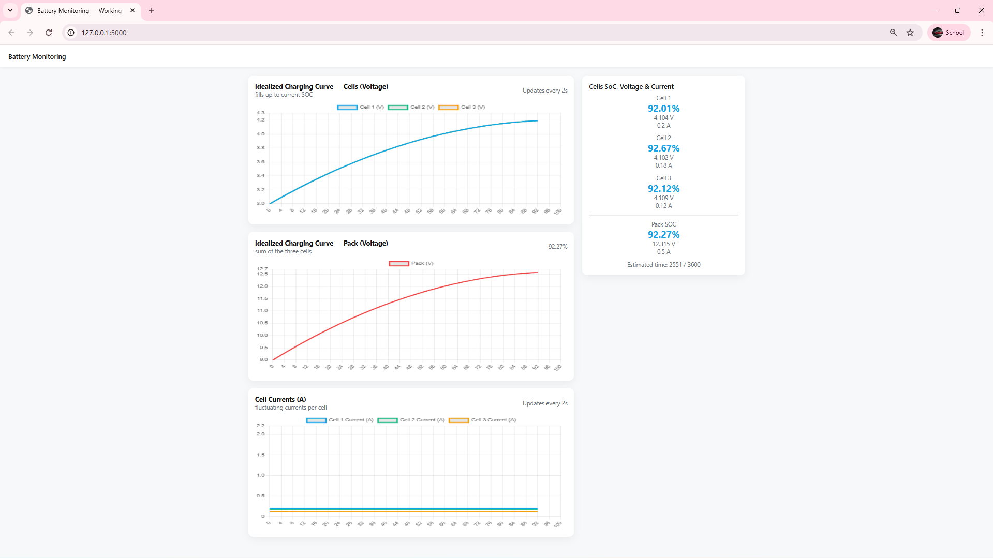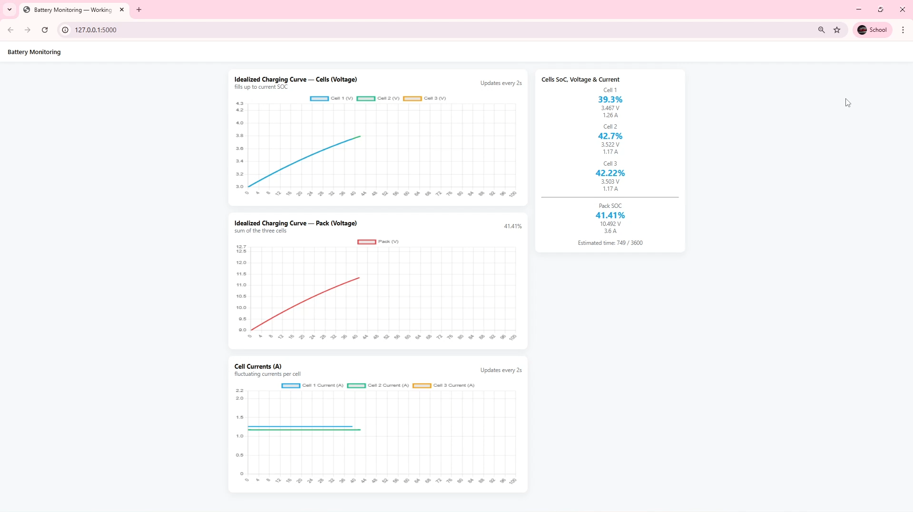
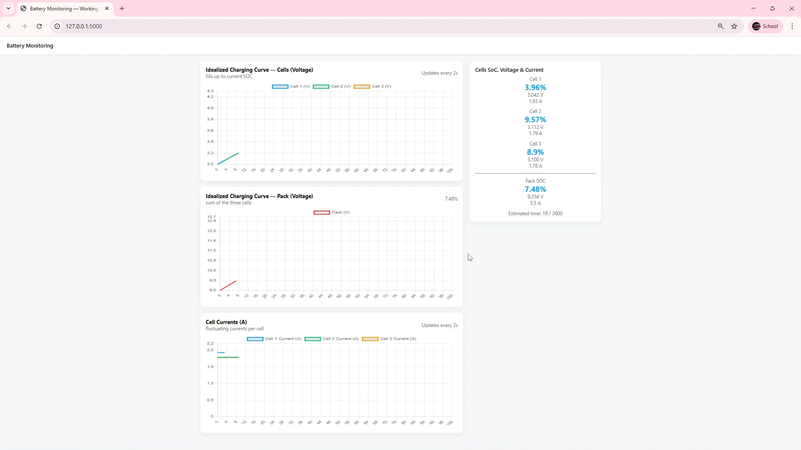

Lab-2

1. Model Bias and Ethical Issues
Domain: Financial Lending
In financial lending, predictive models are used to assess an applicant’s creditworthiness. However, if the training data reflect historical inequalities, such as lower approval rates for certain demographic groups, the model may unintentionally perpetuate discrimination. For instance, a credit scoring algorithm trained primarily on data from high-income regions may rate applicants from low-income or minority communities as higher-risk, not because of actual credit behavior, but due to socioeconomic patterns in the dataset.
To mitigate bias, several steps can be taken:
- Data Auditing: Identify and remove or adjust biased features such as race, gender, or ZIP code that act as proxies for sensitive attributes.
- Fairness-aware Algorithms: Use techniques like adversarial debiasing or equalized odds post-processing to ensure fair treatment across groups.
- Regular Monitoring: Continuously evaluate model performance for fairness metrics such as disparate impact ratio.
- Human Oversight: Combine algorithmic recommendations with expert judgment to prevent automated discrimination.
Addressing these ethical issues helps financial institutions promote fairness, trust, and compliance with regulations like the Equal Credit Opportunity Act (ECOA).

2. Prediction vs. Causal Inference
Example: Customer Churn Prediction
Predictive analytics focuses on forecasting future outcomes. For example, a model may predict which customers are likely to cancel their subscriptions based on behavioral data such as login frequency or purchase history. However, this does not reveal why customers leave.
Causal inference, on the other hand, aims to understand cause-and-effect relationships. For instance, running an A/B test could reveal that customers receiving personalized emails are 20% less likely to churn—indicating that communication frequency causes retention.
Both are essential: prediction allows companies to take proactive measures (e.g., offering discounts to at-risk users), while causal inference informs strategic decisions (e.g., improving customer service to reduce churn long-term). Without causal understanding, interventions may be ineffective or even counterproductive. Thus, predictive accuracy and causal reasoning must complement each other in modern analytics.

3. Business Decision Case: E-Commerce Advertising Optimization
Data Sources:
- Customer demographics, browsing and purchase history, ad click-through data, session duration, and social media engagement.
Algorithms:
- Classification models (e.g., logistic regression, random forest) to identify high-conversion customers.
- Time-series forecasting to predict demand cycles and optimal ad timing.
- Clustering (K-Means) to segment customers based on preferences.
Model Evaluation:
- Metrics: Accuracy, Precision, Recall, F1-Score, AUC-ROC curve.
- Cross-validation for performance reliability.
Applications:
- Personalized ad targeting, recommendation systems, and dynamic pricing.
Limitations:
- Data privacy concerns under GDPR/CCPA.
- Model drift due to changing consumer behavior.
- Over-reliance on algorithms may overlook qualitative insights like brand perception.
An integrated analytics plan helps optimize advertising ROI, but ethical and transparency considerations remain crucial.

4. Risk Management Case: Customer Default Prediction

Variables Used:
- Credit score, income, employment stability, loan amount, repayment history, number of existing loans, and spending behavior.
Balancing Risk and Customer Experience:
Banks must reduce default risk while avoiding unfair rejection of reliable applicants. Explainable AI (XAI) techniques can make risk scores more transparent, helping loan officers justify decisions and maintain customer trust. Offering alternative credit evaluations (e.g., cash-flow-based scoring) can also ensure inclusion.
Impact of Model Errors:
- False Positive (predicting default when the customer won’t): leads to rejected loans, harming customer satisfaction and reputation.
- False Negative (predicting safe when default occurs): causes financial losses and higher risk exposure.
Balancing precision and recall is vital to maintain fairness, profitability, and trust.

5. Essay: Challenges and Developments of Predictive Analytics in the Next 10 Years

Predictive analytics is rapidly evolving due to advances in artificial intelligence (AI), big data, and cloud computing. Over the next decade, several developments and challenges will shape its trajectory.
Technological Advances:
Integration of AI and machine learning will lead to more accurate and adaptive predictive systems. Techniques like deep learning and reinforcement learning will enhance pattern recognition in complex, high-volume data streams from IoT sensors, healthcare devices, and smart cities. Edge computing will enable real-time predictions directly at the data source, reducing latency and improving responsiveness.
Data Privacy and Regulation:
With massive data collection comes heightened concern for privacy. Governments will likely strengthen data protection laws, requiring organizations to implement privacy-by-design principles. Federated learning and differential privacy will emerge as essential methods to train models without exposing sensitive information.
Ethical and Social Challenges:
Bias, fairness, and transparency will remain central issues. Predictive models used in credit scoring, hiring, or policing can reinforce systemic inequalities if not properly managed. The demand for explainable AI will grow to ensure decisions are interpretable and accountable.
Cross-Disciplinary Applications:
Predictive analytics will expand into areas like personalized medicine, environmental forecasting, and smart infrastructure. For example, hospitals may use real-time patient monitoring to anticipate health risks, while cities will predict traffic congestion using IoT networks.
Opportunities and Risks:
While predictive analytics promises efficiency, safety, and innovation, misuse or misinterpretation could lead to privacy breaches, over-automation, or ethical conflicts. Therefore, collaboration among technologists, policymakers, and ethicists will be essential to harness its potential responsibly.
In summary, the next ten years will define how predictive analytics balances technological progress with ethical integrity, shaping its role as a cornerstone of the intelligent digital era.

Lab 3 :
Learning Comments :
In Task 1, I focused on tuning the real-time multi-cell battery monitoring system to make it more stable and visually informative. This included improving the data smoothing algorithm, adjusting the dashboard UI for a more responsive and user-friendly layout, and making the charts fluctuate realistically to simulate real charging behavior. Although debugging the Flask web interface and synchronizing live updates from the ESP32 was a bit difficult at first, the process helped me deeply understand the integration of hardware data with web visualization. The improved dashboard provided a much better experience, showing clearer voltage, current, and SoC readings in real-time, which felt rewarding after fine-tuning the system.
Task 2, which involved answering the predictive analytics lab questions, was more theory-driven but equally valuable. It required critical thinking about real-world issues such as model bias, ethical decision-making, and the balance between predictive accuracy and causality. Writing about these topics helped me connect technical analytics concepts to their social and business impacts.
Overall, both tasks complemented each other — one strengthened my technical and design skills, while the other deepened my analytical and ethical understanding of data-driven systems

Lab5 Video Link
Record a video of approximately 3 minutes to explain your research process. The video should include the following:
1.A description of the tools or methods used during your research process.
2. Present all the processes and outcomes from LAB1 to LAB2.
Link: https://youtu.be/W3YZA1s6LjA?si=L6rIwDcZaPLjcyRe

Thank you

